**Creekside Preschool**



**Parent Orientation**

**Preschool Teacher**

Daisy Cai

**Phone: (858)-391-1514 ext2122 E-mail: dcai@powayusd.com**

**Philosophy **

The first five years of a child‘s life are the most important years of their development. They discover the world around them and begin to develop many skills they will need to succeed in life. Our program is designed to nurture the whole child through an enriching and integrated curriculum. The goal of the program is to offer your child an opportunity to develop his/her emotional, social and academic skills. Our learning environment is built around the child’s need for nurturing relationships, safety, comfort, emotional expression, social interaction and intellectual stimulation. Whenever possible, we modify our environment and adapt it to meet children’s individual needs, instead of adapt children to the environment.

Parents are a crucial part of a child’s development. They are a child’s very first teacher. They are the most important people in a child’s life. They provide the child with guidance, encouragement, and positive, loving home environment. Together, parents and teachers support and encourage children to be the best they can be.

**Goals**

**The preschool environment will…**

* Encourage confidence and independence
* Provide opportunities for creative expression through music and art
* Develop the love of learning and reading
* Encourage problem solving skills
* Develop mathematical awareness
* Encourage a positive social and emotional development
* Encourage science exploration and discoveries

**Hours of Operation MM900283583[1]**

**The preschool opens at 7:00 am and ends at 5:45 pm for full day students. Actual class instruction time is provided from 8:30am to 11:30 with the remainder of the day consisting of coordinated class activities.**

**There is a late fee if your child is not picked up by 5:45 pm. Late pick up fees will be charged as follows:**

**0 to 10 minutes late, the late pick up fee is $1.00 per minute.**

**11 to 30 minutes late, the late pick-up fee is $30.00.**

**31 to 60 minutes late, the pick-up fee is $60.**

**Please try to drop your child in class before 8:45 am. MM900283636[1]**

**If you are going to be late please call and let us know. If you do come in after 8:45 a.m. please come in quietly to minimize distraction at circle time. Circle time is an important part of the curriculum and will begin promptly at 8:45 am.**

**Emergency Information-Disaster Release Form**

**Creekside Preschool is required to have a signed consent form for Emergency Notification and for Disaster Release. In case of emergency or injury, we will immediately attempt to contact the child’s parents. An ambulance will be called if necessary. Please make sure that all contact information is current and that all information of alternative emergency contact is also current. We will follow the request of the parent and contact any other designated emergency contact persons, only if the parents cannot be reached. All parents are required to fill out an emergency card.**

**Emergency Drill**

**Our class will regularly participate in our school wide emergency drills. These drills include fire evacuation, earthquake, and lockdown drills. We do these drills to prepare ourselves for any situation.**

**Disaster Procedure**

**In the event of a natural disaster, the child will be taken care of at school until a parent, or an adult designated by the parent, comes to pick the child up. In the event that no one comes to pick up the child before dark, the child will be taken care of at a safe location designated by PUSD until the parent or designated adult comes to pick him/her up. The child will never be left alone and will remain with the teacher for up to 36 hours.**

**Procedure for Arrival and Pick Up**

**Your child must be delivered and signed into preschool class everyday by someone designated on your registration form. Sign –in/out sheets require daily verification of student arrival/departure times and must include a complete signature.**

**If at any time a person other than a parent or guardian is to pick up your child, a note signed by a parent or guardian must be given to the teacher.**

**Identification with a photo ID must be available at all times.**

**Health Requirements **

**Children must be in good health to attend Creekside Preschool. Children who are observed to be in ill health upon arrival will be asked to return home. Medication can be given to your child upon completion of an H-26 Medical Authorization Form by both the parents/guardian and physician. For your convenience, you can list the medicines your child needs at school on the form. For example, medicine for asthma, allergy medicine, Tylenol, coughs medicine, anti-itch cream for bug bites etc. The medication must be brought to school in its original container.**

**If a child has a temperature before coming to school, please keep him/her at home at least 24 hours.**

**Please keep your child at home if:**

1. **Your child is taking medication, unless the doctor has given permission for your child to attend school**
2. **Your child has a heavy nasal discharge**
3. **Your child has a constant cough**
4. **Your child is not well enough to play outside**
5. **Your child has a fever or has had a fever during the past 24 hours**
6. **Vomiting**
7. **Diarrhea**

**Outside play is an important part of your child’s day. If you feel that your child cannot participate in outside activities on a particular day, it is recommended that you keep him/her at home.**

**If your child has been exposed to a communicable disease, please inform the school immediately. You will be notified if your child has been exposed to a communicable disease at school.**

**Please list any allergies that your child may have. Include any specific sensitivity such as insect stings, grass, etc.**

**Parent/School Communication **

**Creekside Preschool believes that home to school communication is one of the utmost importance for your child’s success in school. We feel that ongoing communication will benefit not only the parent and teacher, but will also add to the child’s well-being.**

**Parents will be informed of their child’s progress through written notices, newsletters, formal and informal conferences.**

**Parent conferences are scheduled twice a year for 4 year old students, and special conferences are available with advanced written notice.**

**Parents are welcome to visit the school at any time. Appointments are not necessary, but are certainly advantageous if there are specifics to be addressed.**

**MAIL BOX **

**The mail box is designed for parents to drop any paper work/notes for school. It is next to the student sign in and sign out sheets. Please feel free to approach Ms. Daisy or leave her a message with any questions or concerns you may have. You may also call and leave a message and we will get it back to you a.s.a.p. Feel free to also e-mail Ms. Daisy. She will respond to e-mails after the children have gone down for naptime.**

**Class Number: 858-391-1514 ext 2122**

**E-mail;** [**dcai@powayusd.com**](mailto:dcai@powayusd.com)

**Parent teacher communication book is next to the Mail Box.**

**Sharing: **

**All sharing will be held on Friday. Please check our monthly calendar for the specific date and time. Their special item may be a picture, toy, book, or anything they want to tell us about. Your child will share their special item during group discussing times. Encourage your child to discuss his/her item. The children will then ask him/her questions about their special items.**

**Birthdays**

**If you would like to celebrate your child’s birthday at school, please notify us ahead of time. You may bring a special snack (store brought only) on that day. Your child can bring one of his/her favorite book to read at school too. We will have a birthday song and each child will take a turn to dance with the birthday boy/girl. Then we will have our “Party” during snack time.**

**Personal Items**

**All clothes that are brought to school must be clearly labeled with your child’s name. A change of clothes must be brought and left at school for any accidents that might occur during the day. Please provide a gallon-sized Ziploc bag labeled with your child’s name containing a complete change of clothing for your child, including socks, and underwear for use in the event of an accident.**

**Emergency BagMM900354479[1]**

**Please pack some snacks and one bottle of water in a Ziploc bag with your child’s name and date packed on it. It will be stored in your child’s cubby. You are responsible to check the emergency food every other three month just in case it is expired.**

**Your Child’s Art**

**We will be doing a lot of art in preschool. Please do not forget to compliment your child’s art. Although it may not seem like much to us, to them it is a beautiful masterpiece complete with a story to tell. Encourage your child to tell you about their drawings and art projects. Praise them and tell them what a great job they have done.**

**Library BooksMM900046560[1]**

**Our class will participate in every other week library visit starting on January each year. They will be read to by our librarian and will be allowed to check books out. If your child forgets to bring his/her book back they will not be allowed to check out another book until the original book is returned.**

**Classroom reading book**

**3 years old:**

**Your child will read one book in the literacy bag together with one of our teacher at school. Then he/she will take the literacy bag home and share it with you.**

**You need to return the literacy bag back to school the following Monday. If your child forgets to return the book to us, he/she will not allow checking out the new book. $15.00 will be charged if you lose our classroom literacy bag.**

**4 years old (Those children who will go to Kindergarten the following school year)**

**Each week your child will learn two sight words from our sight word reading book and she /he will share his/her reading with you at home. Please buy the following book case either from Amazon.com or Scholastic B**ook **Club. Every 4 year old student needs Sight Reading Parent Packet in school before Sep 5th.**

# Sight Word Readers Parent Pack:

# Learning the First 50 Sight Words Is a Snap! [Paperback]

[Scholastic](http://www.amazon.com/s/ref=ntt_athr_dp_sr_1?_encoding=UTF8&sort=relevancerank&search-alias=books&ie=UTF8&field-author=Scholastic) <- Click here to buy. 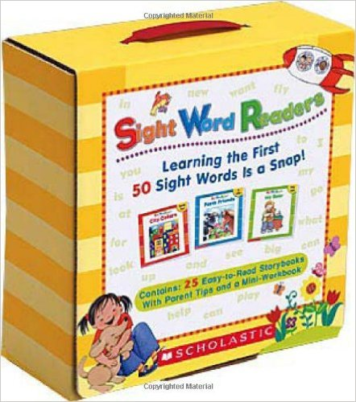

**You can buy it on line or in the bookstore.**

**Get Set for School- For all students.**

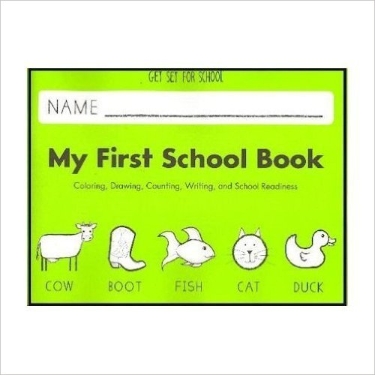

[**Purchase**](http://www.amazon.com/School-First-Handwriting-Without-Tears/dp/1934825530) **🡨 Click here to buy.**

|  |
| --- |
|  |

**Field Trips**

**During the school year we will try our hardest to take the children on field trips. You will be notified of any planned field trips ahead of time to allow you to accompany us.**

**More information will be provided as field trips are planned.**

**Toys**

**Toys of any kind are only allowed during designated class sharing**

**times.**

**What Do I bring to school?**

**Lunch**

* **Bring Lunch: A sturdy clearly labeled lunch box or bag, containing items from each food group, along with a reusable cup and containers if necessary. Unacceptable lunch items include any food containing excessive sugar, corn syrup, sucrose or dextrose.**
* **Buy Lunch: If you would like your child to buy lunch at school, please write a check payable to PUSD Food Service at the beginning of each month. You will pay it to the school office or pay it online. The classroom teacher will not be responsible for lunch money.**
* **Each meal is $2.75. You need to mark “buy lunch” on the sign in sheet each morning if your child will buy lunch that day. A monthly preschool lunch menu will be posted and each parent will receive a copy through e-mail.**

**SnackMM900041044[1]**

**Please note that you will pack an afternoon snack for your child and morning snack will be provided by school daily. However, these are just snacks, and it is our expectation that our students eat a nutritional breakfast each day as well.**

**Dress Code**

**We expect students to be dressed comfortably in attire appropriate for daily activities. CLOSED TOE and CLOSED HEEL shoes are required at all times. Jewelry is disallowed for safety reasons.**

**Nap Items:**

**(Does not apply to part time students) A labeled sheet, small light blanket and optional small pillow. All nap items will be sent home each Friday to be laundered and returned with your child on his/her next school day. All children must lie down and rest for at least one hour during nap time.**

**Mat sheet: You can buy one at Lakeshore . No crib sheet or large twin sheet in school this school year. Thank you for your cooperation!**

**Lakeshore Cot Sheet**

Polyester/cotton sheet has elastic bands to hold it in place for a snug fit. Machine washable and dryer-safe.

[**Purchase mat sheet by clicking here.**](http://www.lakeshorelearning.com/product/productDet.jsp?productItemID=1689949371896002&utm_source=google&utm_medium=ppc&utm_campaign=PLA&CAWELAID=520011010000003105&CAGPSPN=pla&catargetid=520011010000052952&cadevice=c&gclid=Cj0KEQjwosK4BRCYhsngx4_SybcBEiQA)

**Sunscreen **

**Please apply sunscreen before class. If you wish for us to apply sunscreen on your child in the afternoon you must provide a signed consent form and provide the sunscreen to be applied.**

**Homework and Classroom work folder**

**A monthly package of Home work copy will be in your child’s file at the beginning of each month . This home work is age appropriate and is designed for parents to do together with their child, 4 years old only. It includes reading, math, singing, drawing and many other fun activities. Please allow your child to draw all of the required drawings on their own.**

**Classroom work folders will be sent home each Friday. Please check your child’s file each Friday.**

**Items Needed the First Day Of school MM900318123[1]**

* **Please download first day packets from www powayusd.com/preschool and return Signature Verification of Receipt of Documents and Release of Information form to school.**
* **Physician’s report ( Need it the first day of school)**
* **Preschool emergency form**
* **Please bring two snap shots, one of your child and one of the families. These will be used for an art project on the first day.**
* **Sun screen form**
* **Creekside and the trail year permission**
* **Signing a form indicating you have read/received a series of documents.**
* **Signing a form indicating they have read/received a series of documents.**

**Your Child will need:**

* **A complete change of clothes in a zip bag with his/her name on**

**It**

* **Emergency water bottle and some snack ( in a zip bag with**

**Your child’s name on it). Replace it every other three months.**

* **Napping items / small staff animal for nap time**
* **School bag for nap items**